AI ASSISTED CODING
ASSIGNMENT -2.2
HALL TICKET NO:2403A52400
BATCH.NO:14
Task Description#1
● Use Gemini in Colab to write a function that filters out all negative numbers from a
given list
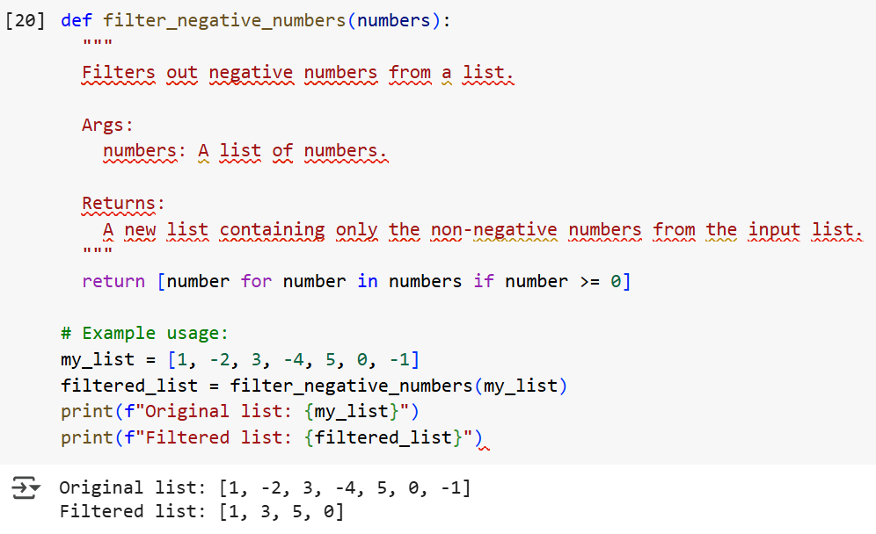
Task Description#2
● Ask Gemini to generate code that reads a text file and counts the frequency of each
word. Then ask it to explain the code.
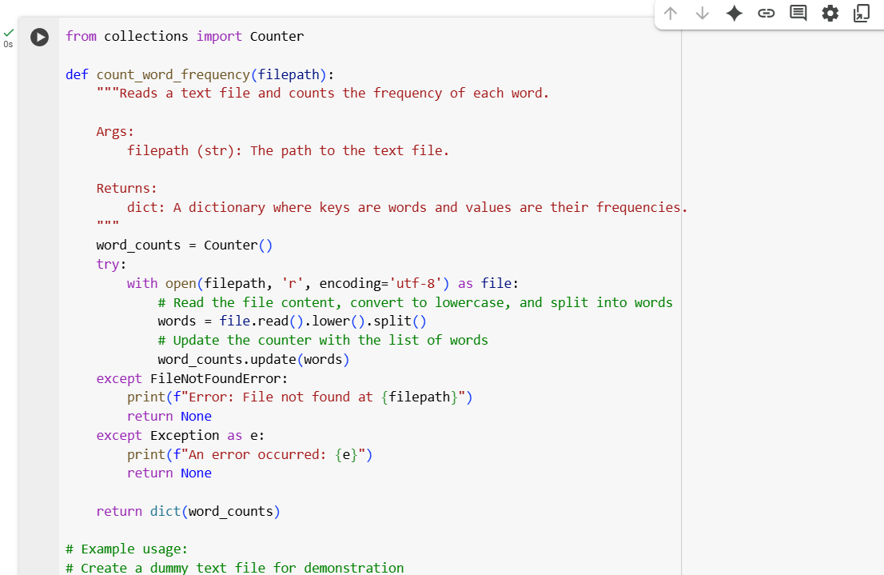
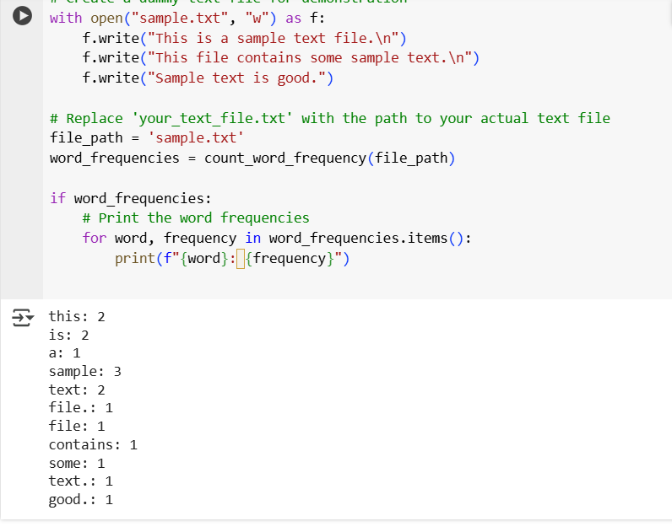
Task Description#3
● Use Cursor AI to generate a Python class called Book with attributes title, author, and
a method summary() that prints the detai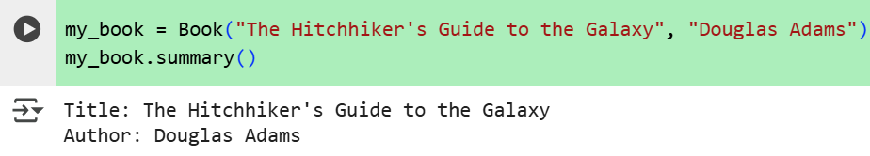
Task Description#4
● Ask Gemini to write a program that checks whether a number is an Armstrong
number, and then modify it using Cursor AI to improve performance or structure
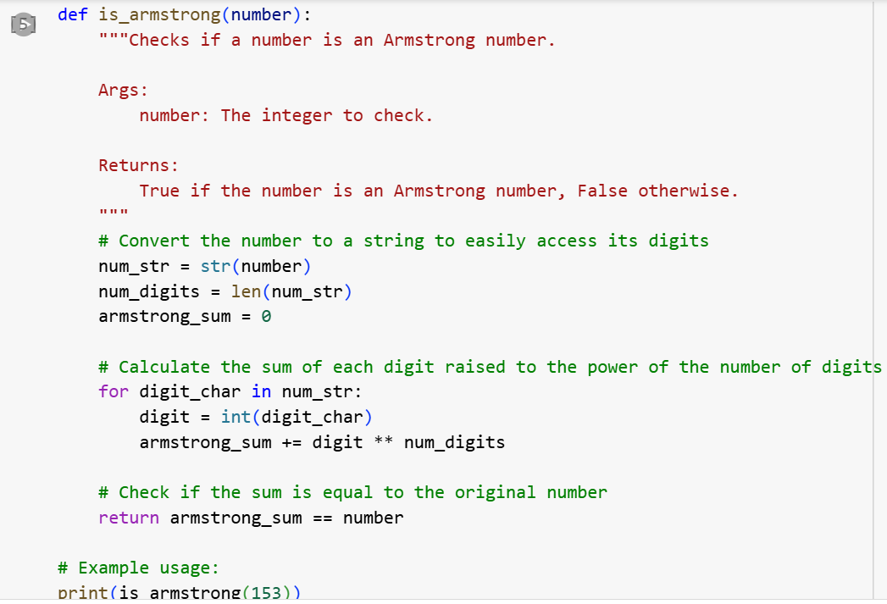
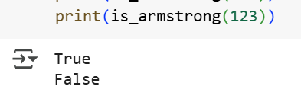

Task Description#5
● Use both Gemini and Cursor AI to generate code for sorting a list of dictionaries by a
specific key (e.g., age).
